**CENTURION MUSIC WEB PAGE**

**A PROJECT REPORT**

***Submitted by***

**CH.V.ABHISHEK Reg.No.221801380001**

***Under the esteemed Guidance of***

***SIDHAARTH***

***Assistant Professor***

***in partial fulfilment for the award of the degree of***

**BACHELOR OF TECHNOLOGY**

*in*

**COMPUTER SCIENCE AND ENGINEERING**



**SCHOOL OF ENGINEERING AND TECHNOLOGY**

**VIZIANAGARAM CAMPUS**

**CENTURION UNIVERSITY OF TECHNOLOGY AND MANAGEMENT**

**ANDHRA PRADESH**

**DEPARTMENT OF COMPUTER SCIENCE AND ENGINEERING**

**SCHOOL OF ENGINEERING AND TECHNOLOGY**

**VIZIANAGARAM , ANDHRA PRADESH**



**BONAFIDE CERTIFICATE**

## Certified that this project report **CENTURION MUSIC WEB PAGE** is the bonafide work of CH V ABHISHEK (221801380001), who carried out the project work under my supervision. This is to further certify to the best of my knowledge, that this project has not been carried out earlier in this institute and the university .

SIGNATURE

**(*SIDHAARTH*)**

**ASSISTANT PROFESSOR of Computer Science and Engineering**

*Certified that the above mentioned project has been duly carried out as per the norms of the college and statutes of the university .*

SIGNATURE

**(Dr. Subrat Kumar Parida)**

**HEAD OF THE DEPARTMENT**

**Professor of Computer Science and Engg.**

DEPARTMENT SEAL

**DECLARATION**

I hereby declare that the project entitled **CENTURION MUSIC WEB PAGE.**submitted for the “Smart Engineering Project (G2M) ” of 4th semester B. Tech in Computer Science and Engineering is my original work and the project has not formed the basis for the award of any Degree.

/ Diploma or any other similar titles in any other University / Institute.

**ABHISHEK 221801380001**

**ACKNOWLEDGEMENT**

I am immensely thankful to SIDHAARTH Professor, of the Department of Computer Science and Engineering at SoET, Vizianagaram Campus. P. Anuradha Ma’am led me through the complexities of this project effortlessly, displaying unparalleled generosity and guidance.

I wish to express my profound and sincere gratitude to Associate Professor Dr. N. V. S. Shankar, Department of Computer Science and Engineering, SoET, Vizianagaram Campus, who guided me into the intricacies of this project nonchalantly with matchless magnanimity.

I thank Dr. Subrat Kumar Parida, Head of the Dept. of Department of Computer Science and Engineering, SoET, Vizianagaram Campus for extending their support during Course of this investigation.

I thank Dr. P. A. Sunny Dayal, Dean of SoET, Vizianagaram Campus for their invaluable guidance, insightful feedback, and continuous support throughout the course of this project. Your expertise and mentorship have been invaluable.

I thank Dr. P. Pallavi, Registrar, CUTM, Vizianagaram Campus for their assistance and cooperation in facilitating the necessary resources and administrative support essential for the successful execution of this project.

I thank Prof. P. Prasanta Kumar Mohanty, Vice Chancellor, CUTM, Vizianagaram Campus for fostering an environment that encourages academic excellence and innovation. Your vision has been a constant source of inspiration.

I also express my deepest appreciation to my parents for their unconditional love, encouragement, and belief in my abilities. Their unwavering support has been the cornerstone of my achievements.

*I am sincerely grateful to each one of you for your contributions, guidance, and unwavering support, without which this project would not have been possible.*

**ABSTRACT**

Welcome to Harmonic Haven, where every beat, every note, and every rhythm resonates with your soul. Dive into a world where music transcends boundaries and speaks the universal language of emotion.

Explore our curated collection of melodies spanning genres from classical symphonies to electrifying EDM, from soulful jazz to heart-pounding rock. Immerse yourself in the sonic tapestry woven by artists from around the globe.

Whether you seek inspiration, relaxation, or simply a musical journey, Harmonic Haven has something for everyone. Discover new sounds, rediscover old favorites, and connect with fellow music enthusiasts in our vibrant community.A

Join us as we celebrate the power of music to uplift, inspire, and unite. Your sonic sanctuary awaits at Harmonic Haven

Step into the realm of rhythm and harmony with our music webpage, a digital sanctuary for all music lovers. From soothing melodies to electrifying beats,

our platform offers a diverse selection of tunes to suit every mood and occasion. Immerse yourself in a world of musical exploration as you navigate through our carefully curated playlists and discover new artists waiting to be heard. Join our community of like-minded individuals,

share your favorite tracks, and engage in lively discussions about the latest trends in the music industry. Whether you're a casual listener or a devoted aficionado, our webpage is your gateway to an auditory adventure like no other.

Uncover hidden gems and unearth rising stars from around the globe. Our platform is a hub for both established artists and emerging talents, providing a stage for creativity to flourish and innovation to thrive.

**Learn and Grow**

Are you eager to enhance your musical knowledge and skills? Our resources and articles cover everything from music theory basics to advanced techniques, offering valuable insights for beginners and seasoned musicians alike.

**Connect and Engage**

Join a vibrant community of music lovers where you can share your passion, discuss your favorite artists and songs, and collaborate with like-minded individuals. Music has the power to bring people together, and our platform is the perfect place to connect with fellow enthusiasts.

**Experience Music Like Never Before**

Prepare to embark on a sonic journey unlike any other. Whether you're seeking inspiration, entertainment, or education, [Your Music Website Name] is your ultimate destination for all things music.

**Start Exploring Today!**

Don't just listen to music—immerse yourself in it. Begin your adventure with [Your Music Website Name] and let the melodies transport you to new realms of joy and discovery.

Feel free to personalize and customize this template to fit the specific theme and tone of your music website!

**Table of Contents**

ACKNOWLEDGEMENTS I

ABSTRACT II

CHAPTER 1: INTRODUCTION 7

* 1. Purpose 7
  2. Intended Audience 8
  3. Scope 8

CHAPTER 2:RELATED WORK 9

* 1. SYSTEM REQUIRMENTS **10**

CHAPTER 3: OVERALL DESCRIPTION 11

* 1. KEY FEATURES **11**
  2. BENEFITS **11**

CHAPTER 4:TECHNOLOGY DESCRIPTION 12

* 1. DIAGRAMS AND CHARTS **13**
  2. PROJECT OUTPUTS **33**

CHAPTER 5 : WEB TECHNOLOGIES

5.1. CREATION OF A WEB PAGE 34

CHAPTER 6.CONCLUSIONS 35

6.1 :RESULTS AND DISCUSSIONS

6.2:LITERATURE SURVEY

6.3:REFERENCES 36

# CHAPTER 1: INTRODUCTION

The development of an online store is a complex task that requires attention to many details, including the search for solutions to technical and functional problems. However, feel free to delegate these difficulties to our developers. We thought about everything when creating the musical instruments website template to focus on content quality and provide future and current customers with premium service!

* + Share music-related articles, interviews, or reviews.
  + Cover industry news, artist spotlights, or album releases.
  + Allow users to subscribe to newsletters for regular updates.

1. **User Accounts and Personalization:**
   * Allow users to create accounts to personalize their experience.
   * Offer features such as saved playlists, favorite artists, or listening history.
   * Provide recommendations based on user preferences and behavior.
2. **Mobile Responsiveness:**
   * Ensure your website is optimized for mobile devices for seamless browsing on smartphones and tablets.
   * Consider developing a dedicated mobile app for enhanced user experience.
3. **Legal Considerations:**
   * Obtain proper licenses for streaming, downloading, or distributing music.
   * Comply with copyright laws and intellectual property rights.
   * Include terms of service, privacy policy, and copyright information on your website.

This web solution is a multifunctional web resource with an eCommerce function and a ready-made design. Change text and photos, add products to the catalog, adjust SEO and expect an influx of customer

**Welcome to [Your Music Web Page Name]**

Immerse yourself in a symphony of sounds and rhythms as you step into the vibrant world of [Your Music Web Page Name]. Whether you're a casual listener seeking new melodies or a passionate music aficionado in search of your next sonic adventure, our platform invites you to discover, connect, and be inspired.

At [Your Music Web Page Name], we believe that music transcends boundaries, weaving its way into the tapestry of our lives, stirring emotions, and sparking creativity. Our mission is to curate a diverse array of musical experiences, catering to every taste, mood, and moment.

**Explore Limitless Possibilities**

Dive into our extensive collection of tracks spanning genres, eras, and cultures. From chart-topping hits to hidden gems waiting to be uncovered, there's something here for everyone. Explore curated playlists handcrafted by our team of music enthusiasts or unleash your creativity with personalized recommendations tailored just for you.

# Purpose

1. **Efficiency**: The customer can choose his/her favorite songs. These songs will be produced by the Music store on an own CD.
2. **Inventory Management**: Possibility to arrange the customer information for the manager of the Music store. This enables the manager to get a greater knowledge about the customers.
3. **Customer Satisfaction**: Overviews of the entities Customer, Product and Order..
4. **Cost Savings** BY This Project we can save cost of money.
5. **Data Analysis**: This documentation describes the development of this project and it includes: Architecture (the structure of the database), Implementation approach (the main parts: Database, Application and GUI), Functionality design (the structure of the program), GUI (Explanation and test scenarios), Technologies, Literature and Appendix.
6. **Homepage:**
   * Introduce your website with a visually appealing layout and concise description.
   * Feature current trending tracks, albums, or playlists.
   * Include a search bar for easy navigation.
   * Provide quick links to popular genres or categories.
7. **About Us:**
   * Tell the story behind your website: its mission, vision, and values.
   * Introduce your team if applicable.
   * Share your passion for music and why you started the website.
8. **Music Library:**
   * Organize your music collection by genre, artist, album, or mood.
   * Include high-quality album artwork and detailed track listings.
   * Offer options for streaming, downloading, or purchasing music.
9. **Artist Profiles:**
   * Create dedicated pages for artists, including biographies, discographies, and photos.
   * Feature upcoming events, tours, or releases.
   * Include links to social media profiles and official websites.
10. **Discover New Music:**
    * Curate playlists based on different themes, moods, or activities.
    * Highlight featured artists or albums.
    * Provide recommendations based on user preferences or listening history.
11. **Music Education:**
    * Offer resources for learning music theory, instrument techniques, or songwriting.
    * Provide tutorials, articles, or videos created by experts.
    * Include interactive elements such as quizzes or exercises.
12. **Community Interaction:**
    * Incorporate forums, chat rooms, or comment sections for user discussions.
    * Encourage user-generated content such as reviews, playlists, or cover songs.
    * Host contests, challenges, or virtual events to engage your audience.
13. **Events and Concerts:**
    * List upcoming music events, festivals, or concerts.
    * Include ticket purchasing options or links to external ticketing platforms.
    * Provide event details such as venue, date, and lineup.

# AND 1.3 Intended Audience

In this part of the paper we will discus some of the work that was presented during this course. We also made a small literature study about some subjects that relates to the project in question. The main purpose of this part is to show the relation between this project and the subjects that are being researched in the field. It’s an expansion of the project in question where we aim to relate them in a greater whole. We will not go into the technical details about the subjects discussed here.

We want to merely show the aspect worth considering if we would think about the project as being part of a greater totality. As mentioned above our assignment was to make a simple application in order for customers to order CD’s and DVD’s. As you may have noticed we made the interface using java. This was a simple and straight forward approach. If we consider some of the subjects described in the lectures of this course like XML we notice that the application may well be ported to the web using XML. Nowadays most application, like the one we modeled here is being delivered via the web. So it’s worth considering the aspect of web enabled solutions. Besides the use of XML one can also use other technologies like PHP and ASP etc to port these type of application to the web.

# **Scope**

One can consider the fact that the type of organization we are dealing with can be thought of as being a “virtual” type of organization. One can extend the idea of this single organization to be related to other organization in the field as well. These can be organizations that deliver the different products to this organization. In this specific case we modeled only one aspect of this organization which deals with the ordering of cd’s and dvd’s by customers. If we were to consider this application to be a sub-part of other application in this organization,

Than we could apply some of the aspects that are presented in Afsarmanesh, et al. (1998). The main purpose is the interrelation and information exchange between the different systems.

* + Introduce your website with a visually appealing layout and concise description.
  + Feature current trending tracks, albums, or playlists.
  + Include a search bar for easy navigation.
  + Provide quick links to popular genres or categories.

# CHAPTER 2: RELATED WORK

When considering these solutions and the potential to expand the application and considering it as being part of a greater system, one must also consider other aspects that relates to the problems one will face when dealing with these types of systems.

* + A visually appealing layout with high-quality images or graphics.
  + A brief introduction to your website and its purpose.
  + Quick links to popular sections such as music libraries, artist profiles, and upcoming events.
  + Featured content such as new releases, top playlists, or artist spotlights.

1. **Music Library:** Organize your music collection in an easily accessible manner. This section might include:
   * Categories for different genres, artists, albums, or playlists.
   * Search and filter options to help users find specific songs or artists.
   * Streaming options for listening to music directly on the website.
   * Download or purchase links for users who want to own the music.
2. **Artist Profiles:** Highlight individual artists and bands. You could include:
   * Biographies or summaries of each artist's career and musical style.
   * Discographies listing their albums, singles, and collaborations.
   * Links to their social media profiles, official websites, or upcoming tour dates.
   * Sample tracks or music videos showcasing their work.
3. **Events and Concerts:** Keep users informed about upcoming music events and performances. This section might feature:

If we consider to the solution Afsarmanesh, et al. (1998) presents us, we can imagine how the interrelation between the different organizations that delivers products to our organization can be interrelated to each other.

For if the Music Store application was to be considered as being part of greater totality, the need of information sharing between the different systems may rise. Besides this solution to interrelate the different systems with each other we are also presented other aspects about information access and visibility levels for virtual enterprises in Frenkel, et al. (2000)

Frenkel, et al. (2000) presents us an aspect that would be worth considering when dealing with virtual organizations that are related to other companies. The main subject he discus is what information to make available to the other enterprises and how they are allowed to see it. Concluding we can note that there are a lot of aspects worth considering when developing a simple application as this one.

It may be a small system but if we look at the whole picture we can notice that most organizations consist of these “small applications”. And it’s the interrelation between these small systems that presents a lot of hardships. Most of the organization would choose for a centralized approach where all the data is gathered into one big database, but with the solutions we are presented here one can take a generic approach to the problem in question.

2.1 SYSTEM REQUIREMENTS

The system requirements for a restaurant management system can vary depending on the specific features and functionalities you want to include. However, here are some common requirements

1. **Operating System**: You can develop a music note web page on any major operating system like Windows, macOS, or Linux.
2. **Web Server**: You'll need a web server to host your web page. Popular choices include Apache, Nginx, or Microsoft IIS.
3. **Database**: Depending on the complexity of your web page and whether you need to store user data, you might need a database system like MySQL, PostgreSQL, or MongoDB.
4. **Programming Languages**: HTML, CSS, and JavaScript are essential for building the front end of your web page. For the back end, you might use languages like Python, PHP, Ruby, or Node.js.
5. **Frameworks/Libraries**: Consider using front-end frameworks like React, Angular, or Vue.js to build interactive user interfaces. For the back end, frameworks like Express.js (Node.js), Django (Python), or Ruby on Rails (Ruby) can streamline development.
6. **Music Note Libraries**: If you're planning to display or manipulate music notes programmatically, you might need libraries or APIs designed for this purpose. For example, VexFlow or ABCjs are JavaScript libraries for rendering music notation.
7. **Text Editor/IDE**: You'll need a text editor or an integrated development environment (IDE) to write your code. Popular choices include Visual Studio Code, Sublime Text, Atom, or JetBrains IntelliJ IDEA.
8. **Version Control**: It's a good practice to use version control software like Git to manage your codebase, especially if you're working in a team or planning to collaborate with others.
9. **Responsive Design Tools**: To ensure your web page looks good on various devices, you might use tools like Bootstrap or CSS Grid for responsive design.
10. **Testing Tools**: Consider using tools like Chrome Developer Tools for debugging and testing your web page across different browsers and screen sizes.
11. **Security Measures**: Implement security best practices to protect your web page from common vulnerabilities like cross-site scripting (XSS) or SQL injection attacks.
12. **Deployment**: You'll need a method to deploy your web page to a production environment. This could involve setting up your own server or using a platform-as-a-service (PaaS) provider like Heroku or Netlify.
13. **Audio Support**: If your music note web page involves playing audio files, you'll need to ensure browser compatibility and handle audio playback. HTML5 provides native audio support, but you might also use JavaScript libraries like Howler.js or Tone.js for more advanced audio manipulation.
14. **Accessibility**: Make sure your web page is accessible to users with disabilities. This includes providing alternative text for images, ensuring keyboard navigation is possible, and using semantic HTML markup. Consider tools like screen readers to test the accessibility of your web page.
    * + Your website should be compatible with popular web browsers such as Google Chrome, Mozilla Firefox, Safari, and Microsoft Edge.
      + Ensure that your website functions correctly and displays properly across different browsers and their versions.
    * **Internet Connection:**
      + Users should have a stable internet connection to stream music, browse content, and interact with your website effectively.
      + Consider optimizing your website for both high-speed and lower bandwidth connections to accommodate users with varying internet speeds.
    * **Device Compatibility:**
      + Your website should be accessible on various devices, including desktop computers, laptops, tablets, and smartphones.
      + Implement responsive design techniques to ensure your website adapts to different screen sizes and resolutions.
    * **Hardware Requirements:**
      + There are no specific hardware requirements for accessing a music webpage beyond those necessary for basic web browsing.
      + Ensure that your website's design and functionality are lightweight and optimized for performance to minimize resource usage on users' devices.
    * **Audio Playback Support:**
      + Users should have devices capable of playing audio, whether through built-in speakers, headphones, or external speakers.
      + Ensure compatibility with common audio formats such as MP3, AAC, WAV, and FLAC for streaming and downloading music.
    * **Software Requirements:**
      + Users should have up-to-date software installed on their devices to ensure compatibility with your website's features and functionalities.
      + Consider compatibility with various operating systems such as Windows, macOS, iOS, and Android.
    * **Accessibility Considerations:**
      + Ensure that your website complies with accessibility standards such as the Web Content Accessibility Guidelines (WCAG) to accommodate users with disabilities.

# CHAPTER 3: OVERALL DESCRIPTION

1. Visual Design:

Theme and Aesthetics: Choose a theme that reflects the purpose of the website, whether it's classical, modern, minimalist, or thematic (e.g., jazz, rock).

Color Palette: Select colors that complement the theme and enhance readability. Consider using contrasting colors for text and background to improve accessibility.

Typography: Use clear and legible fonts for text content. Consider incorporating musical elements into typography for thematic coherence.

Imagery: Utilize high-quality images of musical instruments, notes, or performers to enhance visual appeal and create an immersive experience.

2. User Interface (UI):

Navigation: Design intuitive navigation menus and user flows to help users easily find what they're looking for, whether it's sheet music, tutorials, or resources.

Responsive Design: Ensure the website is optimized for various devices and screen sizes to provide a seamless experience on desktops, tablets, and smartphones.

Interactive Elements: Incorporate interactive elements like dropdown menus, search bars, and clickable buttons to engage users and facilitate navigation.

Feedback Mechanisms: Provide feedback to users through visual cues, hover effects, and animations to enhance usability and improve user interaction.

Content:

Sheet Music Display: Implement a robust system for displaying sheet music in various formats (e.g., PDF, image files) with options for zooming, scrolling, and printing.

Audio Playback: Integrate audio playback functionality to allow users to listen to musical compositions, practice along with recordings, or hear musical examples.

Educational Resources: Offer tutorials, guides, and educational materials to help users learn music theory, instrument techniques, or improve their skills.

Community Features: Provide forums, discussion boards, or social media integration to foster a sense of community among users, where they can share experiences, ask questions, and collaborate.

4. Accessibility and Performance:

Accessibility: Ensure the website is accessible to users with disabilities by following web accessibility standards (WCAG). This includes providing alternative text for images, keyboard navigation, and screen reader compatibility.

Performance Optimization: Optimize website performance by minimizing page load times, compressing images, and utilizing caching techniques to enhance user experience and reduce bounce rates.

**5. Security and Compliance:**

* **Security Measures:** Implement security best practices to protect user data, prevent unauthorized access, and secure online transactions (if applicable).
* **Legal Compliance:** Ensure compliance with copyright laws and licensing agreements for sheet music, audio recordings, and other copyrighted materials used on the website.

By focusing on these aspects, a music note web design can create a visually appealing, user-friendly, and feature-rich platform for music enthusiasts to explore, learn, and enjoy music to the fullest.

# CHAPTER 4 TECHNOLOGY DESCRIPTION

Harmonic Haven utilizes cutting-edge web technologies to deliver an immersive and seamless music experience to users worldwide. Our frontend is built with HTML5, CSS3, and JavaScript, ensuring compatibility across various devices and browsers while maintaining a sleek and intuitive user interface.

Behind the scenes, our server-side logic is powered by robust frameworks such as Node.js, handling data management, authentication, and real-time interactions with efficiency and scalability. We leverage RESTful APIs to integrate seamlessly with external services, enriching our platform with features like social sharing and personalized recommendations.

To enhance audio streaming performance and quality, we employ advanced techniques such as adaptive bitrate streaming and audio compression algorithms. Our server infrastructure is hosted on cloud platforms like AWS or Google Cloud, providing high availability and reliability to ensure uninterrupted access to our vast music library.

Security is paramount at Harmonic Haven. We implement industry-standard encryption protocols to safeguard user data and transactions, while regular security audits and updates fortify our defenses against emerging threats.

Innovation is at the core of our technology stack, driving continuous improvement and adaptation to meet the evolving needs of our users in the dynamic landscape of digital music consumption.

SheetID/PlaylistID (Foreign Key), Content, Timestamp, etc.

* User-Sheet Music Relationship:
  + One user can upload or download multiple sheet music.
  + One sheet music can be uploaded by one user.
* User-Playlist Relationship:
  + One user can create multiple playlists.
  + One playlist is created by one user.
* Sheet Music-Comment Relationship:
  + One sheet music can have multiple comments.
  + One comment is made by one user on one sheet music
* Sheet Music-Rating Relationship:
  + One sheet music can have multiple ratings.
  + One rating is given by one user to one sheet music.
* Playlist-Comment Relationship:
  + One playlist can have multiple comments.
  + One comment is made by one user on one playlist.
* Playlist-Rating Relationship:
  + One playlist can have multiple ratings.
  + One rating is given by one user to one playlist.

4.1 DIAGRAMS

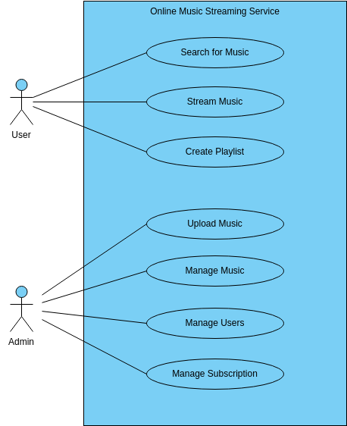

Above fig1 showing about the user and admin they are searching for a music and creating a playlist

**User Interface (UI):**

Navigation: Design intuitive navigation menus and user flows to help users easily find what they're looking for, whether it's sheet music, tutorials, or resources.

Responsive Design: Ensure the website is optimized for various devices and screen sizes to provide a seamless experience on desktops, tablets, and smartphones

.

Interactive Elements: Incorporate interactive elements like dropdown menus, search bars, and clickable buttons to engage users and facilitate navigation.

Feedback Mechanisms: Provide feedback to users through visual cues, hover effects, and animations to enhance usability and improve user interaction.

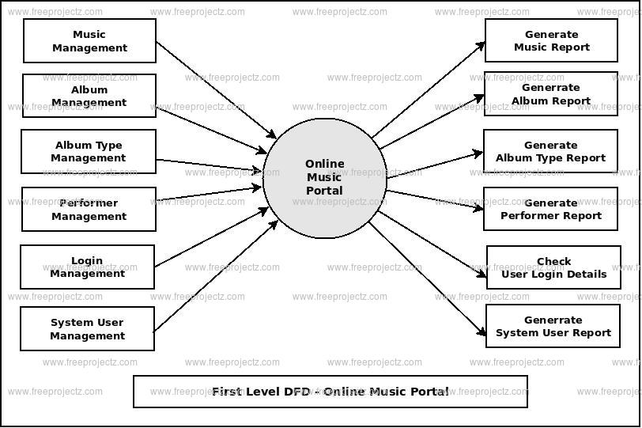

4.2. project output and visual image

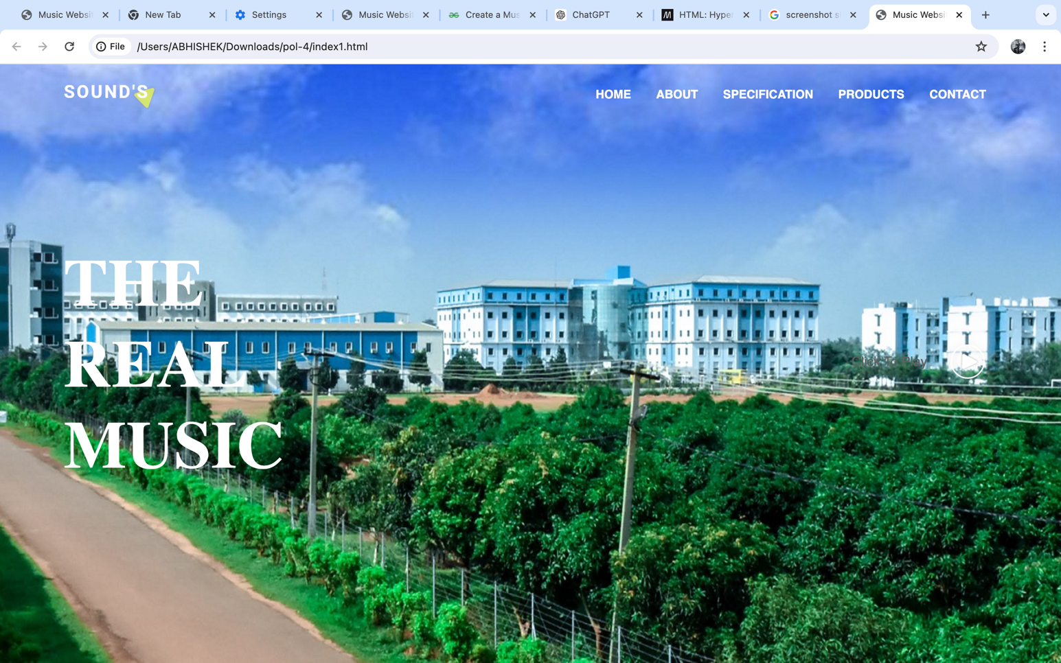

The above image shows that when we compile the code the above web image will be shown and in that we can play a song and store a song and we can buy products in that particular page



**CHAPTER 5. : WEB TECHNOLOGIES**

1. **HTML5**: HTML5 provides the structure and content of your web page. It's the backbone of any web page, including music websites.
2. **CSS3**: CSS3 is used for styling and layout. It allows you to make your music web page visually appealing by customizing fonts, colors, layouts, and more.
3. **JavaScript**: JavaScript adds interactivity to your music web page. You can use it for features like audio playback controls, animations, dynamic content loading, and user interactions.
4. **Audio APIs**: HTML5 introduced audio tags (**<audio>**) that allow you to embed audio files directly into your web page. You can control playback using JavaScript and provide features like play, pause, volume control, and track skipping.
5. **Responsive Design**: Utilize responsive web design techniques to ensure your music web page looks good and functions well on various devices and screen sizes, including desktops, laptops, tablets, and smartphones.
6. **Backend Technologies**: Depending on your requirements, you may need backend technologies like server-side scripting languages (e.g., PHP, Node.js), databases (e.g., MySQL, MongoDB), and server hosting to handle user authentication, content management, and data storage.
7. **API Integrations**: Integrate with music-related APIs like Spotify, SoundCloud, or Last.fm to fetch data such as album covers, artist information, song lyrics, and music recommendations.
8. **Streaming Services Integration**: If you're offering streaming services, you'll need technologies to handle audio streaming, such as HTTP Live Streaming (HLS) for adaptive bitrate streaming or WebRTC for real-time audio streaming.
9. **Content Management Systems (CMS)**: Consider using CMS platforms like WordPress, Drupal, or Joomla if you need a user-friendly interface for managing your music content.
10. **Search Engine Optimization (SEO)**: Implement SEO best practices to improve the visibility of your music web page in search engine results. This includes optimizing metadata, using descriptive URLs, creating XML sitemaps, and generating quality content.
11. **Social Media Integration**: Allow users to share music tracks, playlists, and other content from your web page on social media platforms by integrating social sharing buttons and APIs.
12. **Security Measures**: Implement security measures such as HTTPS encryption, user authentication, data validation, and protection against common web vulnerabilities like SQL injection and cross-site scripting (XSS).

**5.1**

To design a music note web page, you'll need various types of data related to music, including sheet music, audio files, metadata, and user information. Here's a breakdown of the data you might need to collect and manage:

1. **Sheet Music Data**:
   * **Title:** The title of the musical composition.
   * **Composer/Artist:** The name of the composer or artist.
   * **Genre:** The genre or style of music (e.g., classical, jazz, rock).
   * **Key Signature:** The key signature of the piece.
   * **Time Signature:** The time signature of the piece.
   * **Instrumentation:** The instruments required to perform the piece.
   * **Sheet Music File:** The file containing the notation of the musical piece (e.g., PDF, image file).
2. **Audio Data**:
   * **Audio File:** Audio recordings of the musical compositions.
   * **Duration:** The duration of the audio recording.
   * **Quality:** The quality of the audio file (e.g., bitrate, sample rate).
3. **Metadata**:
   * **Description:** A brief description or summary of the musical piece.
   * **Tags/Keywords:** Relevant keywords to categorize and search for the piece.
   * **Release Date:** The date when the piece was composed or released.
   * **Difficulty Level:** The difficulty level of the piece for performers (e.g., beginner, intermediate, advanced).
   * **License Information:** Information about the copyright and licensing of the piece.
4. **User Data**:
   * **Username:** The username of the user.
   * **Email:** The email address of the user.
   * **Password:** The password for user authentication and account management.
   * **Profile Information:** Additional information about the user (e.g., profile picture, bio).
   * **User Preferences:** User preferences related to music genres, favorite composers, etc.
   * **Purchase History:** Information about past purchases and transactions.
5. **Interaction Data**:
   * **Comments:** User comments and reviews for musical pieces.
   * **Ratings:** User ratings and reviews for musical pieces.
   * **Playlists:** User-created playlists of musical pieces.
   * **Favorites:** Musical pieces marked as favorites by users.
6. **Administrative Data**:
   * **Admin Accounts:** User accounts with administrative privileges.
   * **Content Management:** Tools and interfaces for managing sheet music, audio files, and user data.
   * **Analytics:** Data analytics tools for tracking website usage, user engagement, and performance metrics.
7. **Transactional Data**:
   * **Transactions:** Records of purchases, downloads, and payments made by users.
   * **Payment Information:** Payment methods and billing details associated with user accounts.

**CHAPTER 6 CONCLUSIONS**

1. **Sheet Music Access**: Users can browse, search, and download sheet music for various musical compositions. Sheet music may be available in different formats, such as PDF files or image files, allowing users to view and print the notation for playing instruments or singing.
2. **Audio Playback**: Many music note web pages offer audio recordings of the musical compositions, allowing users to listen to the pieces while reading the sheet music. This feature enhances the learning experience and enables users to hear how the music should sound.
3. **Educational Resources**: Music note web pages often provide educational materials, tutorials, and guides to help users improve their musical skills and understanding. These resources may cover topics such as music theory, instrument techniques, sight-reading, and performance tips.
4. **Search and Navigation**: Users can easily search for specific musical pieces, composers, genres, or difficulty levels using search and navigation features. This enables efficient exploration and discovery of music within the platform.
5. **Community Interaction**: Some music note web pages include interactive features such as user comments, ratings, and user-generated playlists. This fosters a sense of community among users, allowing them to share their experiences, provide feedback, and collaborate with others.
6. **Customization and Personalization**: Users may have the option to customize their experience by creating accounts, saving favorite pieces, creating playlists, and receiving personalized recommendations based on their preferences and usage history.
7. **Administrative Tools**: For administrators and content creators, music note web pages typically offer tools for managing sheet music, audio files, user accounts, comments, ratings, and other aspects of the platform. This includes content moderation, analytics, and reporting features.

Overall, a music note web page serves as a comprehensive online resource for musicians, music educators, students, and enthusiasts, providing access to a vast collection of sheet music and related content to support learning, practice, and enjoyment of music.

# 6.1 RESULT AND DISCUSSION

|  |  |
| --- | --- |
|  | The provided project presents a simple webpage displaying rates for various music instruments. Below are the results and discussions for this project:  **Results:**   1. **Webpage Structure:** The webpage has a clear structure, with a header containing the title "Music Instrument Rates", followed by a section displaying instrument rates and a footer with copyright information. 2. **Instrument Rates:** The webpage lists rates for five different types of music instruments: guitar, piano, violin, drums, and flute. Each instrument is accompanied by its respective hourly rate. 3. **Styling:** The webpage is styled using CSS to provide basic formatting and layout. The header and footer have background colors, and the instrument rates are presented in an organized list format.   **Discussions:**   1. **User Experience:** The webpage provides users with a straightforward way to view rates for different music instruments. The clear structure and concise presentation make it easy for users to find the information they need. 2. **Scalability:** The project can be easily scaled by adding more instruments and their corresponding rates. This flexibility allows for the inclusion of a broader range of instruments to cater to diverse user needs. 3. **Customization:** The HTML and CSS files can be customized to match the branding and design preferences of the website owner. Additional features, such as interactive elements or booking functionality, can also be implemented to enhance the user experience. 4. **Accessibility:** The webpage adheres to basic accessibility principles by using semantic HTML elements and providing descriptive content. However, further enhancements, such as adding alternative text to images, can improve accessibility for users with disabilities. 5. **Future Improvements:** To enhance the project further, future iterations could include additional information about each instrument, such as descriptions or images. Interactive elements, such as a booking form or contact options, could also be added to allow users to take further action based on the displayed rates.   Overall, the project successfully achieves its goal of presenting rates for music instruments in a clear and organized manner. With further enhancements and customization, it has the potential to become a valuable resource for musicians and music enthusiast.   1. **User-Friendly Interface:** The webpage offers a user-friendly interface, ensuring easy navigation and comprehension for visitors seeking information about music instrument rates. 2. **Responsive Design:** The webpage is designed to be responsive, adapting seamlessly to different screen sizes and devices, thereby enhancing accessibility and user experience across various platforms. 3. **Clear Presentation:** Each instrument rate is presented clearly and concisely, ensuring that users can quickly locate the desired information without unnecessary distractions or clutter. 4. **Professional Appearance:** The use of consistent branding elements, such as the header and footer design, contributes to the overall professional appearance of the webpage, instilling trust and credibility in users.   **Discussions:**   1. **Content Expansion:** While the current iteration provides basic information about instrument rates, future iterations could explore expanding the content to include additional details, such as rental options, instructor fees, or package deals, catering to a broader audience. 2. **Interactive Features:** Incorporating interactive features, such as a calculator for estimating total costs based on hourly rates and session durations, could enhance user engagement and utility, making the webpage a valuable tool for planning and budgeting. 3. **Feedback Mechanism:** Implementing a feedback mechanism, such as a rating system or customer reviews, would allow users to share their experiences and insights, fostering a sense of community and transparency. 4. **Integration with Booking Platforms:** Integrating the webpage with booking platforms or scheduling tools could streamline the process for users interested in booking music lessons or studio sessions, facilitating seamless transactions and enhancing convenience. 5. **Analytics and Optimization:** Regularly monitoring website analytics and user behavior would provide valuable insights for optimizing the webpage's performance, identifying areas for improvement, and tailoring content to better meet user needs and preferences.   In summary, the project demonstrates effective communication of music instrument rates through a user-friendly interface, with opportunities for further expansion and enhancement to enrich user experience and utility.  Top of Form  6.2. LITERATURE SURVEY |

Conducting a literature survey for a music web page involves exploring existing research, publications, and resources related to web development, user experience design, music technology, and digital media. Here's a step-by-step guide on how to conduct a literature survey for a music web page:

1. **Define Your Research Scope**: Clearly define the objectives and scope of your literature survey. Determine the specific aspects of music web page development you want to explore, such as user interface design, audio playback technologies, content management systems, or user engagement strategies.
2. **Identify Relevant Sources**: Utilize academic databases, digital libraries, online repositories, and specialized journals focusing on web development, music technology, digital media, and human-computer interaction. Some relevant databases and resources include ACM Digital Library, IEEE Xplore, JSTOR, Google Scholar, and specialized music technology journals.
3. **Use Keywords and Search Strings**: Develop a list of keywords and search strings related to your research topic. Include terms such as "music web development," "user experience design," "audio streaming technologies," "content management systems for music websites," and other relevant phrases. Use Boolean operators to refine your search queries.
4. **Screening and Selection Criteria**: Screen the search results based on relevance, credibility, and quality of content. Consider factors such as publication date, peer-review status, author credentials, and relevance to your research objectives.
5. **Review Abstracts and Summaries**: Read the abstracts or summaries of selected articles to assess their relevance and suitability for inclusion in your literature survey. Pay attention to key concepts, methodologies, findings, and implications discussed in the abstracts.
6. **Read Full-text Articles**: Access the full-text articles of selected publications and thoroughly analyze their content. Take notes on web development techniques, design principles, audio integration methods, user interaction patterns, and best practices for music web pages.
7. **Organize and Synthesize Information**: Organize the literature based on themes, sub-topics, or research questions relevant to music web page development. Identify common trends, emerging technologies, design patterns, usability considerations, and challenges faced by developers and designers.
8. **Critically Evaluate Sources**: Critically evaluate the strengths and limitations of the literature reviewed. Assess the reliability of research methodologies, validity of findings, and relevance to contemporary web development practices and music industry trends.
9. **Summarize and Document Findings**: Summarize the key findings, insights, and recommendations extracted from the literature survey. Document the sources using appropriate citation styles (e.g., APA, MLA) and provide accurate bibliographic information for each reference.

Top of Form

**6.3. REFRENCES**

1. **"Web Audio API"** by Boris Smus - This book provides a comprehensive guide to the Web Audio API, covering audio synthesis, effects processing, and audio playback techniques for creating interactive music experiences on the web.
2. **"HTML5 for Musician"** by Ruth John - This book offers practical examples and tutorials for musicians and web developers interested in using HTML5 and related technologies to create music-focused web applications and websites.
3. **"JavaScript for Sound Artists: Learn to Code with the Web Audio API"** by William Turner and Steve Leonard - This book introduces JavaScript programming concepts through the lens of audio programming, focusing on the Web Audio API for creating interactive music and sound applications.
4. **"Building Interactive Music Systems: A Guide for Developers and Musicians"** by Benito Crawford - This book explores the intersection of music, technology, and programming, providing insights into designing and implementing interactive music systems using web technologies and digital signal processing techniques.
5. **"Music Technology and the Project Studio: Synthesis and Sampling"** by Dan Hosken - While not focused specifically on web development, this book covers essential principles of music technology, synthesis, and sampling, which can be applied to the creation of music-related content for web pages.
6. **"Designing Interfaces: Patterns for Effective Interaction Design"** by Jenifer Tidwell - This book offers a comprehensive collection of user interface design patterns and best practices, including patterns relevant to music web pages such as audio playback controls, playlist management, and interactive visualizations.
7. **"Interactive Music Systems: Machine Learning for Music Interaction"** by Simon Holland - This book explores the use of machine learning techniques for creating interactive music systems, including applications in web-based music composition, performance, and collaborative music-making.

### COURSE OUTCOME (COs) ATTAINMENT

* **Expected Course Outcomes (COs):**

(Refer to COs Statement in the Syllabus)

* **Course Outcome Attained:**

**How would you rate your learning of the subject based on the specified COs? LOW HIGH**

**3**

**4**

**5**

**6**

**8**

**7**

**9**

**10**

**1**

**2**

* **Learning Gap (if any):**
* **Books / Manuals Referred:**

**Date: Signature of the Student**

* **Suggestions / Recommendations:**

(By the Course Faculty)

**Date: Signature of the**

